**Project Report II- DELTA**

**Team Members:**

1. Anitta Davis Mundassery
2. Archana Sekhar
3. Eza Mariyam Robin
4. Sandra Anna Biju

**Domain:** Software

**Project Abstract:**

The project "Heim" is designed to develop a user-friendly website that provides detailed information about hostels and PGs (Paying Guest) accommodations near Govt. Model Engineering College. The platform aims to make it easier for students to find suitable accommodations by offering key features such as search functionality, filter options (PG/Hostel, Boys/Girls ), and a responsive interface. Built with React for the front end, the website ensures a responsive and engaging user experience. Users will be able to view accommodation details through cards that display essential information like price, address and contact details. Additionally, Heim allows users to update and insert new information, keeping the listings current and accurate. The back end of the website is powered by Spring Boot, and the data is stored and managed using MySQL. Overall this project is focused on creating an efficient and dynamic platform for users to explore various accommodation options around the college.

**Working of the Project:**

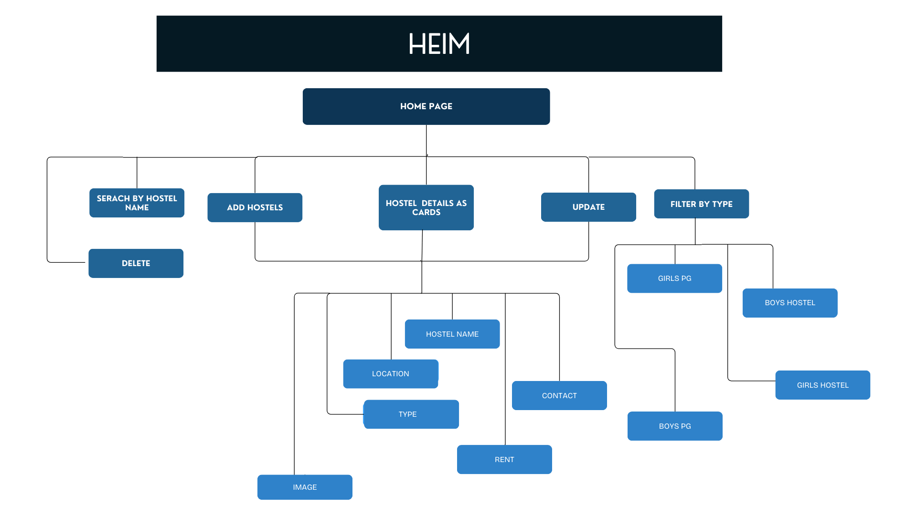

**Tech Stacks Used:**

Front-end : React

Back-end : Spring Boot

Database : MySQL

**Total Cost for the project:** Nil

**Images:**

Back-end

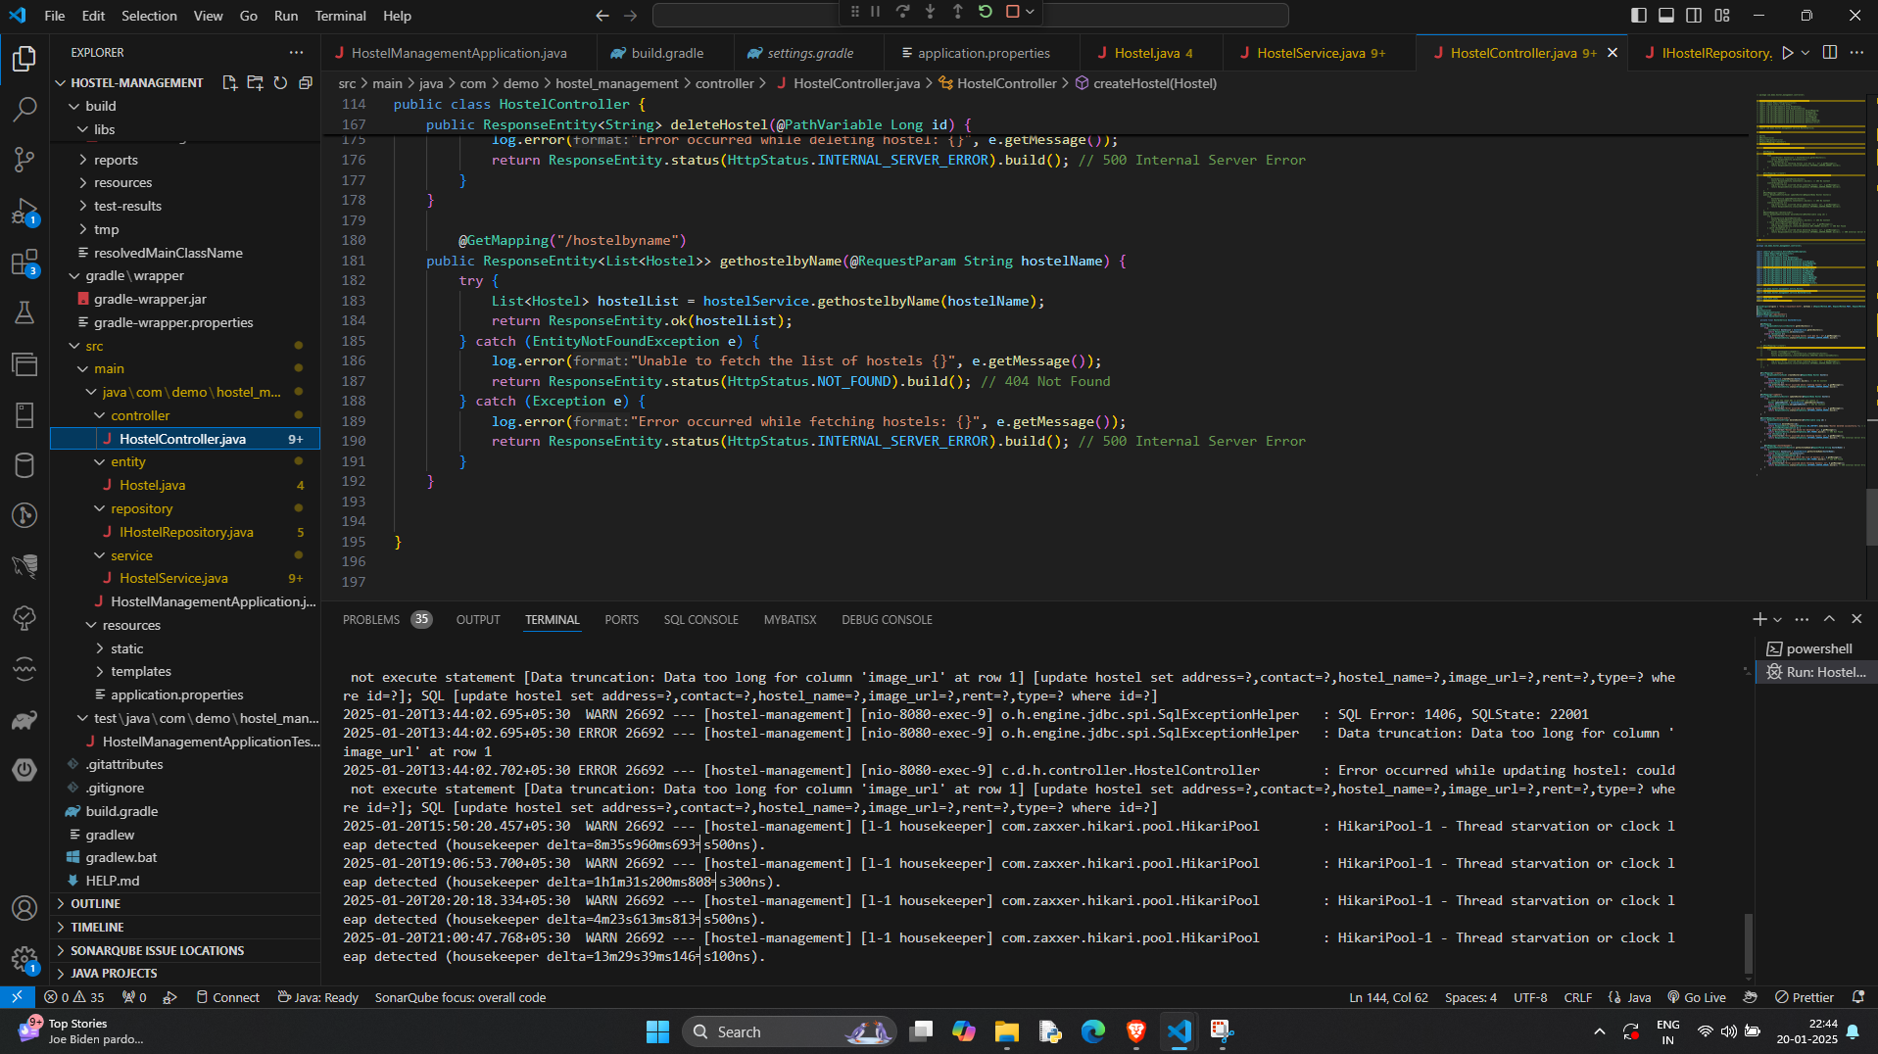

Front-end

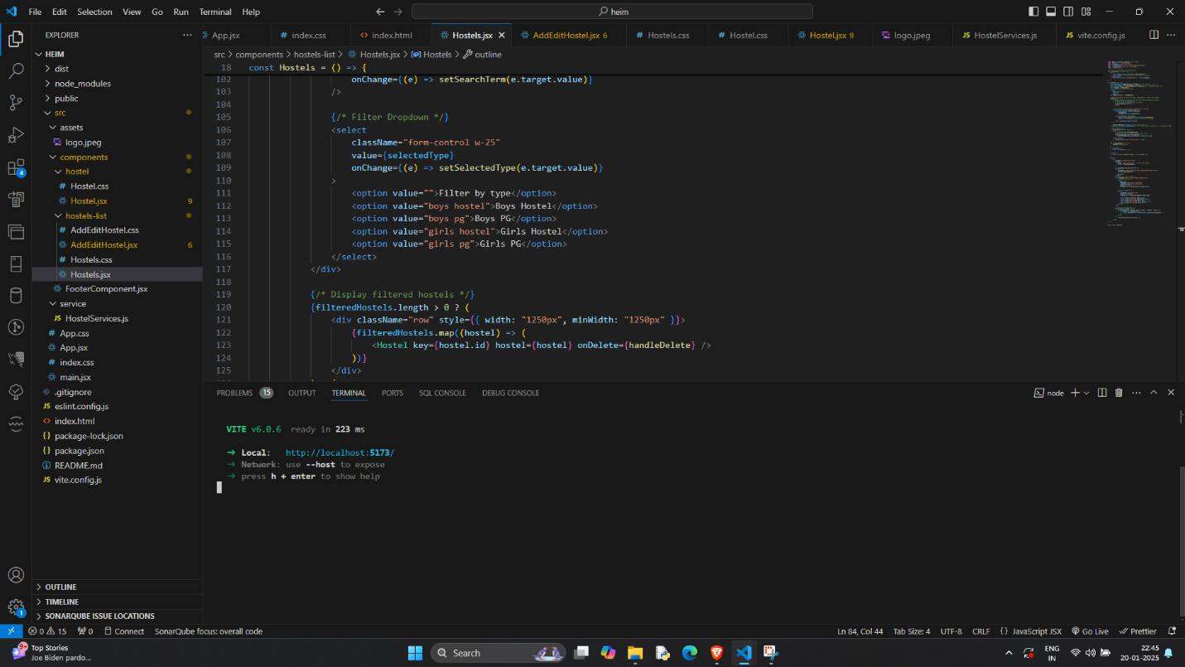

**Project working video:**

<https://drive.google.com/file/d/1z0F2RYBYS6MPQHqeSQ3AYcG48MtDBItj/view?usp=drivesdk>